

|  |
| --- |
| Mediolanum / Misys |
| Funding & Hedging Orders on Foreign Currency Securities |
| FusionInvest Toolkit |

|  |
| --- |
|  |



**© Misys Limited   
All rights reserved**

**Registered in   
England & Wales**

No. 01360027

**Registered Office:**One Kingdom Street Paddington   
London W2 6BL  
United Kingdom

Contents

Introduction 3

Document purpose 3

Reference Document 3

Assumptions and Constraints 4

Creating Funding and Hedging orders 5

General process: 5

Detailed steps of Funding/ Hedging creation: 5

Linking the FX spots and Forwards to a position: 8

FX Forwards rolling 8

FX Rolling mechanism: 8

FX Rolling Link maintenance: 9

Portfolio views/Extractions/FO Ranking views 11

Walkthrough example – without the toolkit 12

|  |  |  |  |  |
| --- | --- | --- | --- | --- |
| ACTION | VERSION | NAME | DATE | COMMENTS |
| Creation | 1.0 | Slim CHENNOUFI | 27-JAN-2016 | 1st version |
| Update | 1.1 | Slim CHENNOUFI | 19-MAY-2016 | Update as per Misys R&D feedback |
| Update | 1.1.1 | Gregory COBENA | 22-JUN-2016 |  |
| Update | 1.2 | Fergus TIMLIN | 29/06/2016 | Mediolanum comments |
| Update | 1.3 | Gregory COBENA  Yuanjia SU | 01-JUL-2016 | Answer Mediolanum question  & Add pictures |
| Update | 1.4 | Yuanjia SU | 01-AUG-2016 | Add allocation rule, order intention functions |
| Update | 1.5 | Yuanjia SU | 24-AUG-2016 | Order amount will be based on execution price (conf. last) |
| Update | 1.6 | Amira Benslimane | 09-Sept-2016 | Following call on 08/09/2016 with Niall S. and Adrian D. |
| Update | 1.7 | Amira Benslimane | 19-Sept-2016 | Following call on 19/09/2016 with Niall S. and Adrian D. |
| Update | 2.0 | Amira Benslimane | 18-Oct-2016 | Following call on 18/10/2016 with Michael P. and Adrian D. |

## Introduction

Document purpose

This document will define the client requirements around two closely related FusionInvest customisations, references “Toolkit – 7 Order Blotter to book FX Forwards and swaps linked to an equity/fixed income order” and “Toolkit – 8 Extraction criteria to view order and linked FX hedge in portfolio”.

Mediolanum would like to be able to automatically create a funding and/or a hedging order when raising an order on equity or fixed income security. Moreover, they would like to be able to view these orders (or trades once executed) grouped together in the portfolio view. This will be applied to simulated orders in the portfolio, real orders in the portfolio and positions/trades.

|  |  |
| --- | --- |
| PRODUCT NAME | Misys FusionInvest |
| PRODUCT VESION  (CURRENT VERSION INSTALLED) | V7.1.3.x |
| PREFERRED TIMEFRAME FOR DELIVERY OF SOLUTION. EXPLAIN AS NECESSARY | Required as part of the Order Raising and Compliance configuration. |
| SHORT DESCRIPTION OF REQUIREMENT | Raising funding an hedging orders on equity/fixed income |

Reference Document

This is the high level outline for both toolkits provided during Project Statement of Work

|  |  |
| --- | --- |
| Toolkit | Book FX hedging transactions on an order |
| Implementation | Customization of the input screen to match the client’s requirements |
| Component | Software development Kit |
| Description | The requirement here is to have the ability to raise an FX spot and forward from the order of an equity or fixed income asset and the percentage of hedging can be assigned. |
| Company Work | Company will define, develop, configure, document and perform unit testing |
| Client Work | Client to test that it matches their requirements  Perform SIT/UAT |

|  |  |
| --- | --- |
| Toolkit | Extraction criteria to link FX hedge and underlying position |
| Implementation | Customization of portfolio slice/dice criteria |
| Component | Software development Kit |
| Description | Based on a parameter in the original order and the associated FX transaction, the executions linked to the original order will be viewed together in the portfolio. |
| Company Work | Company will define, develop, configure, document and perform unit testing |
| Client Work | Client to test that it matches their requirements  Perform SIT/UAT |

No further reference documentation will be needed.

Assumptions and Constraints

Here is a summary of assumptions, details are in next section.

Book FX Transactions

* Is a user-action in “Order Blotter”
* Is a “one-time” user-action and does not replicate further modifications on either side

Extraction criteria to link FX hedge and underlying position

* Is designed for “on-demand” display that will load as an “extraction” (time/performance)
* Is not applicable for Compliance
* Is not applicable to Performance Attribution

## Creating Funding and Hedging orders

General process:

In the “Order Blotter”, upon selection of one order or several orders, FusionInvest will propose a workflow action offering the choice to:

* Create a funding order for the total or a part of the foreign currency amount
* Create a hedging order for the total or a part of the foreign currency amount

It should be noted that the creation of those FX orders is a usability feature, which replaces a manual entry by an automated one. This is a one-time action and this is *not* the definition of a parent/child relation between orders where the modification of one would automatically be reflecting in the other.

The funding and hedging amounts do not have to be identical.This action will correspond to workflow status(es) and this will give a possibility to use Order Blotter view according to those status(es).

Detailed steps of Funding/ Hedging creation:

When 1 equity/fixed income order is selected, the customization will automate the following steps, which could be performed manually by the user:

* The user will manually select .

The proportion of funding order and hedging order will be defined separately, and will be displayed in the follow manner:

|  |  |  |  |  |
| --- | --- | --- | --- | --- |
|  | Spot order proportion | Hedging order proportion | %NAV – Hedging | %NAV - Funding |
| Fund1 | 100% | 40% | ([Hedging%*executed amount]/NAV )*100% | ([Funding%*executed amount ]/NAV)*100% |
| Fund2 | 100% | 10% |  |  |
| Fund3 | 100% | 50% |  |  |

* Spot order proportion and hedging order proportion are editable, %NAV columns are for display only.
* There will be a ‘Propagate Changes’ box to propagate the percentages entered on one fund onto the other funds of the list.
* Only the funds that are part of the parent’s order allocations are going to be displayed in this screen.
* When multiple parent orders are selected, the user will have 2 options
* Apply the same choice of Funding and/or Hedging percentage to all parent selected
* Input a Funding and/or Hedging percentage for each selected parent order (default will be previous values, so that user only has to click “ok” when the same parameters apply)

The “Set as default percentages for all orders” choice is meant to apply the current percentages to all selected orders instead of handling them one by one. Otherwise, if the user selects an order, the parameters will only apply to that order.

* In the same GUI select the user will be able to manually select ‘Create’. This generates the FX spots and FX forwards according to the table above.
* The currencies are automatically detected: currency of the order to hedge against the currency of the Fund/Strategy (default market way will be used)
* The hedging amount is set according to two already defined fields: hedging order proportion and parent order amount (we will use Quantity * exSecution price when this amount is not defined)

* FX date is selected according to:
* Parent settlement date, in the case of Spot funding
* A date to be selected by the user in a pre-defined list, in the case of forward hedging order. This list will be pre-configured in a standard bucket set and shared between all users.

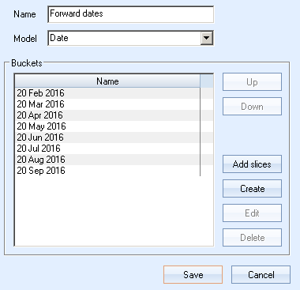

* The allocation is copied from parent order to the FX Order. These allocations can be overwritten if the user decides to apply a default allocation rule.

Default allocation rules will be set up in the standard trade allocation rule tab, and will be visible in this toolkited GUI. Proportions are also manually editable.

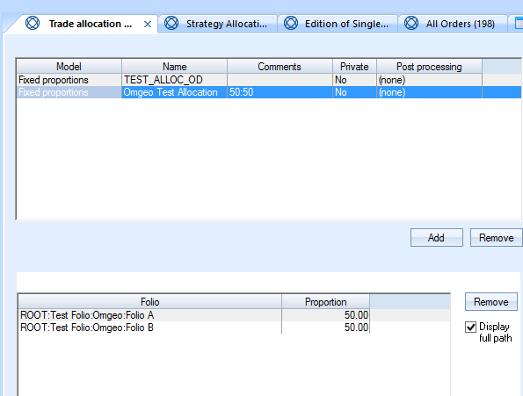

Screenshot for illustration purposes – pending development.

These funding and hedging allocations which are generated are based on the full value of the parent position which is executed on each fund. Therefore the spot order and hedge order proportions in the table above are based on this value.

**Example:**

If the parent order is allocated to Fund1 30%and Fund2 70%, both the funding and the hedging orders should have the same allocations as their parent order, always based on the executed quantity. For example an order of 100$ APPLE I allocated to 30%Fund 1 and 70%Fund 2. If only 80% of the order is executed. We will generate funding/hedging for 80% and split the 80% onto the funds respectively 70% and 30%. So it will be 56% and 24% of the initial order amount/quantity.

## Linking the FX spots and Forwards to a position:

It is important to note that FX Spots and Forwards are linked to the position and not to each trade behind this position. This is to enable users to have a condensed view of their position’s strategy.

The example below illustrates the need to have this when we create a new trade on an existing position.

**Example:**

Fund_A (EUR) holds a position on Share_A (USD) of 100$. This is funded with a EUR/USD spot and hedged with FX FWD EUR/USD 100$.

When I increase my exposure to Share_A to 150$, the new grouping in the toolkited extraction will be as follows:

{Fund_A, Share_A, Spot 100$, Spot 50$, FX FWD 100$, FX FWD 50$}



## FX Forwards rolling

FX Forward rolls are part of this toolkit as we need to link old FX FWD positions with their rolls.

FX Rolling mechanism:

Once a portfolio is selected, FX forwards are displayed according to the specified range of dates:



The end user will then select the ones that need to be rolled. This offers more flexibility than setting up a default mechanism and gives a larger view of what is available in the portfolio.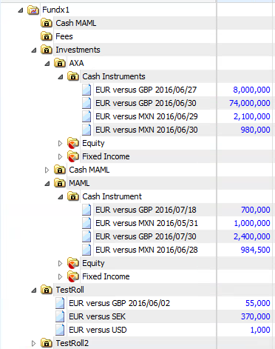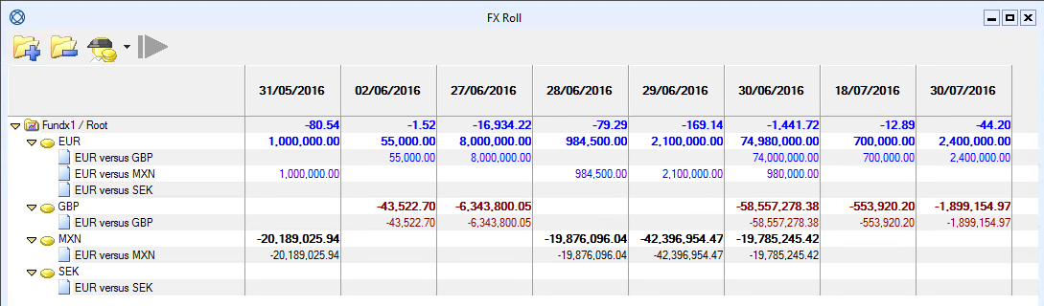

User then selects the positions to roll from the GUI and new target expiry dates from a calendar.

FX Rolling Link maintenance:

A link between the rolled FX forwards will need to be created.

Every FX forward is linked to the position and the instrument. Therefore every roll will be linked to previous FX Forwards, position and instrument.

This means that FX Forwards will need to have a roll attached to each individually. Therefore separate orders are to be created for each roll.

Under the same fund we might open a position1 with exposure x% on date 1, that we will hedge and link to an FX FWD1 x%.

On date 2 we might open a position2 with exposure y%, that we will hedge and link to an FX FWD2 y%.

In the portfolio view (without the toolkit) we will have one position with exposure x+y% and two FX FWDs.

In the toolkited extraction we will maintain the link between the position and its two hedging forwards.

This way when the FX Forward is rolled we will maintain a historical connection of the rolls to the position on the instrument. So we will have (position, old FXFWD1, rolled FXFWD1,old FXFWD2, rolled FXFWD2).

The rolling of each FX forward will correspond to one order in Fusion Invest. If the orders need to be grouped to send one FX Forward to the market with x+y% it will need to be done outside Fusion Invest. The executions should be sent back on each order and will be retrieved on the appropriate position.

Same mechanism if positions are across several funds.

**Example:**

Fund1 EUR

Share1 USD - - FX Spot1 – FX FWD 1_date D

Share2 USD - - FX Spot2 – FX FWD 2_date D

Fund2 EUR

Share1 USD - - FX Spot4 – FX FWD 4_date D

Share3 USD - - FX Spot3 – FX FWD 3_date D

When the user decides to roll all 4 FX Forwards that expire on date D, he will use the GUI described in the FX Rolling mechanism section and have them displayed. He will then select them and choose a new date (date D2) and roll. The orders will be created in the blotter (2 for each roll one closing the existing FX FWD trade and one opening the new trade).

In the blotter the user can do a multiple selection and send them all to the execution platform. The orders will be sent separately and the execution platform (FX ALL) will manage the grouping of these orders and the netting. Once executed Fusion Invest will receive back 4 executions to dispatch on each of the original orders and create the corresponding trades.

The extraction with the roll taken into account will be as follows:

Fund1 EUR

Share1 USD - - FX Spot1 – FX FWD 1_date D– FX FWD 5_date D2

Share2 USD - - FX Spot2 – FX FWD 2_date D– FX FWD 6_date D2

Fund2 EUR

Share1 USD - - FX Spot4 – FX FWD 4_date D– FX FWD 7_date D2

Share3 USD - - FX Spot3 – FX FWD 3_date D– FX FWD 8_date D2

## Portfolio views/Extractions/FO Ranking views

In the portfolio view, Mediolanum would like to have a display offering the possibility to group each parent order/parent position/parent trade with its funding and hedging orders/positions/trades.

This will not be applied to the simulated orders.

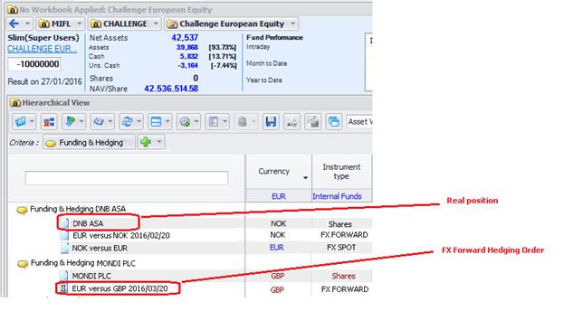

Screenshot for illustration purposes – pending development

The criterion above should be available in the extractions configuration.

The display will be available by running an extraction, including this criterion on the portfolio. It should be noted that that this will take some calculation time – typically the same as other extractions with trade-based criteria.

This criterion and display:

* Is available on demand ; but is not designed for use in Compliance rules nor performance attribution; and in particular is not designed to impact other indicators with Netting between hedged/hedging items

Is only designed to provide **netted totals** of some indicators (P&L, Greeks), in the same way that those indicators are summed with other extraction criteria.

The possibility to use the FO Ranking criteria will be given in this extraction. For this we will use a toolkited criteria defined as follows:

Ranking of grouped position = ranking of the parent order.

Example: {APPLE,EUR vs USD FWD} will fall under Equity

## Walkthrough example – without the toolkit

This section presents the step-by-step manual creation of the FX orders; **without The Toolkit.** The goal is to define exactly what the Toolkit will do by showing how the same could be done manually.

By automating those steps, the Toolkit will:

* Improve usability (number of clicks & user actions)
* Reduce operational risk

In this example, we start from 2 orders on “BOUYGUES” which have been created using dynamic order builder

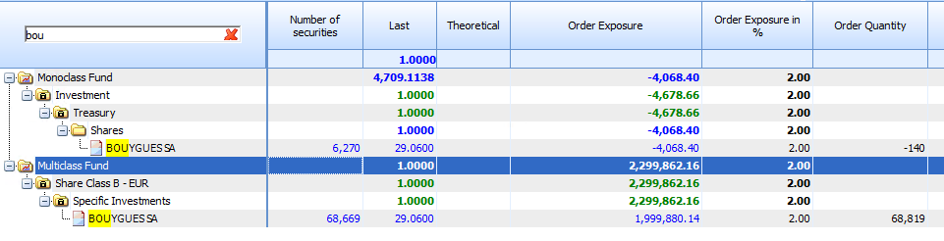

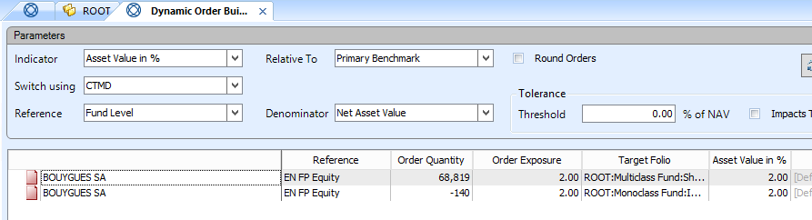

Without loss of generality, we assume that the 2 orders have been merged into one. It is then possible to have the Order Amount or to re-estimate it using the Quantities and Last Price.

The currency is also retrieved and the FX funding/hedging orders can be created when it differs from the Fund/Strategy currency.

In our example:

* Parent Order currency is EUR
* Fund currency is GBP

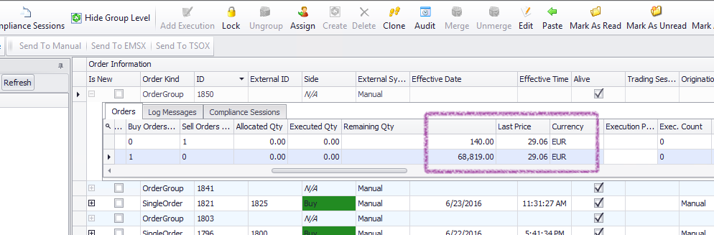The user decides to create a Funding order and/or a Hedging order. The percentages are also defined.

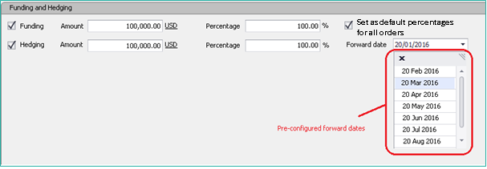

For Hedging order, the list are selected from a pre-defined list in a “Bucked Set” configuration

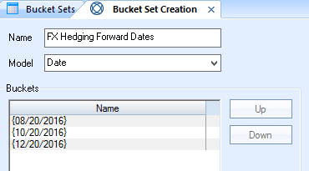

The FX funding order is created to fund (or hedge) the EUR amount against GBP.

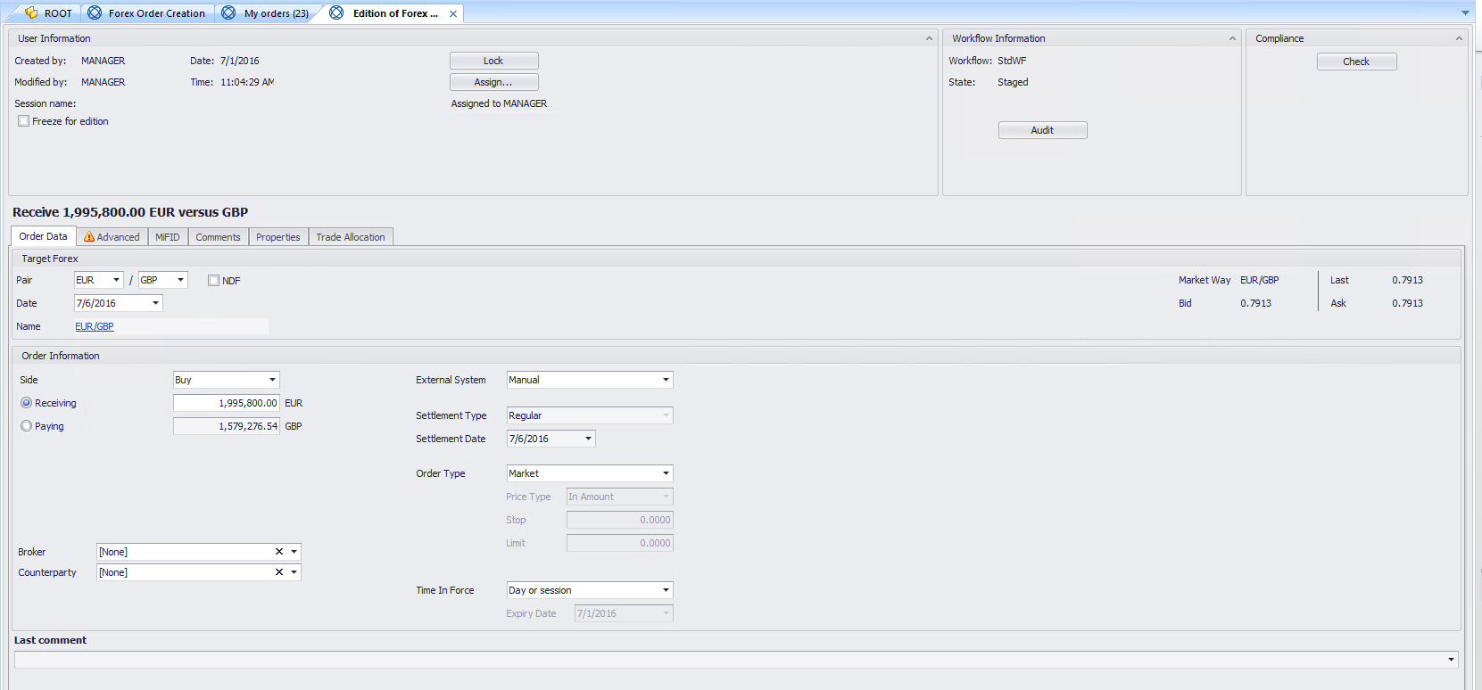

The allocation is copied from the parent order…

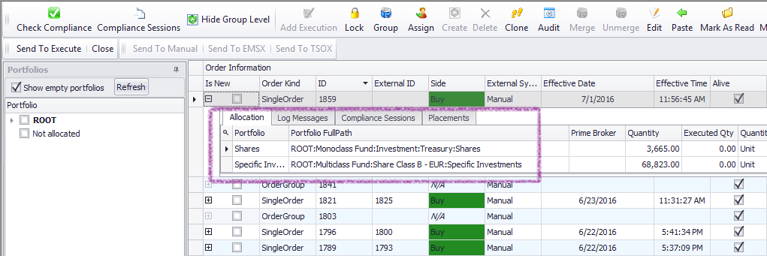

… to the FX order

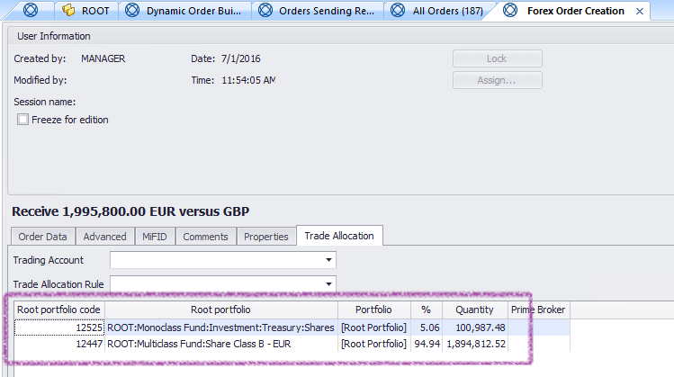

The order group-id is modifying according to parent order. Also the “Property” is marked with a unique identifier.

The property will be propagated from the Order to the Executions and into the Trade ticket in portfolio (cf. next section on the “criterion”).

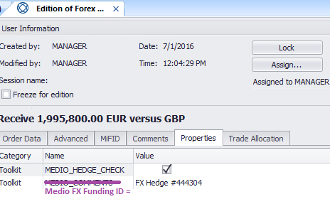

The property can also be used to filter the list of orders in Order Blotter

